**Information Security Blog Website Report Essay**

Fadel BABA-MOUSSA

Northern Arizona University

PLD450

01/31/2023

**INTRODUCTION**

All Bachelor of Science Computer Information Technology (CIT) students are required to complete a practical project at the end of their degree. The goal is to show that beyond the theory, students are capable of tackling tasks that they will more than likely face during their careers, especially at the beginning, for those without on-the-field experience.

The course description itself initially led me to believe that this was another writing project, where deliverables would be the technical documentation pertaining to the said project. My initial understanding of the course requirements quickly came to a halt with mounting confusion due to another course (BBA465C) I was doing concurrently, which had a Capstone project. I decided to seek clarification from my professor, which led me to take a Software Development Life Cycle (SDLC) approach to this whole project. Therefore, I will take you through the Planning, Requirements Analysis, Design, Development, Testing, and Deployment phases of this project.

**Planning**

The initial meeting with the Professor was over a video call, and she explained that this was not another essay but an actual project that needed to be implemented. She provided me with examples of the type of projects that other students have done in the past, and which fields they selected. That’s how we discussed projects like knowledge bases, websites, blogs, etc., in fields like Project Management, Information Security, and Quality assurance, and ended up settling on a project: A website blog that would discuss Project Management topics, with emphasis on showcasing basic HTML knowledge.

We also discussed the deliverables related to this course, which included a proposal, a journal of activities, the actual project, its timeline, and the report that you are currently reading.

Unfortunately, due to personal reasons and tight deadlines related to other courses, I was not able to complete the project during that semester and had to report completing it the following semester. The long timeline led to more confusion as the course objectives were updated on the website and it led me to understand that **BBA465C** for which I was doing a Capstone in Information Security, had to be the same topic as **PLD450** for which I was planning to Project Management.

Another call was necessary to clear it out, and Professor Copley, not only explained to me that the topics, while they could be the same, do not have to be, but also provided additional guidance on the project expectations. Since I was already writing about Information Security, I settled on doing the blog website on that topic instead of Project Management as we initially agreed upon.

I researched the web to find information security topics I could blog about, and needless to say, there was plenty to choose from. To keep my focus on the actual technical aspect of the project, I selected a few topics from articles I found about the CIA triad, Information Security basics, prevention measures, phishing, and the security risks caused by humans.

**Requirements Analysis**

With a clear understanding of what to work on, it was time to move on to the requirement analysis phase of the product, which is not to be confused with the requirements for the course (proposal, journal, implementation, report) previously discussed above.

For the product itself, the requirements were the following:

* A blog website built with HTML.
* It could be very basic with a simple page or be more involved with CSS and other complex designs, as the student sees fit.
* It should at least contain a few blog entries on the selected subject. Mine being Information Security it could subjects like VPN, SSL, and internet attacks, to name a few, but the focus of the project isn’t really the topic discussed but the technical aspect of the site implementation.
* The product had to be built using a GitHub repository.
* The product should not be built using templates from website-building platforms such as WIX, WordPress, etc.

**Design phase**

For the design of my blog website, I took an exploratory approach, meaning I tried to familiarize myself as much as possible with the types of blog websites available out there, and see if their format could be interesting to inspire me for my own work. Even though my project was not expected to reach that level of complexity, it was interesting to see what could be done with HTML and how CSS can literally transform the site from an aesthetic and user experience standpoint.

My research led me to visit quite a few websites to accomplish the above, such as:

* <https://firstsiteguide.com/examples-of-blogs/>
* <https://www.hostinger.com/tutorials/blog-examples>
* <https://blog.feedspot.com/best_blogs/>

These sites themselves had compilations of other blogs, so I had more than enough material to analyze and come up with my own design, which I wanted to be simple and efficient.

I settled for a format that will include:

* A header, to introduce my blog name and goal
* Two pages, one being the home/landing page and the other a contact page.
* A navigation bar with clickable buttons for each page
* The main page will be divided into two columns, one for my blog entries and the other one for information about myself and other links related to the project.
* A footer for website-related notes.
* The color set would be mostly grey, black, and some blue for the hyperlinks.

Professor Copley and I previously discussed including a map mind for the site and I think this was a good idea. It helped me structure my site and be better organized during the design and implementation phases. I explored several mind-mapping tools like MindNode, MindMeister, Coggle, and Bubbl. I ended up selecting the latter because it was free, as some of the others but more intuitive from my point of view. I was able to quickly create a simple, yet neat and efficient mind map for my site as displayed below, to guide me into the development phase.

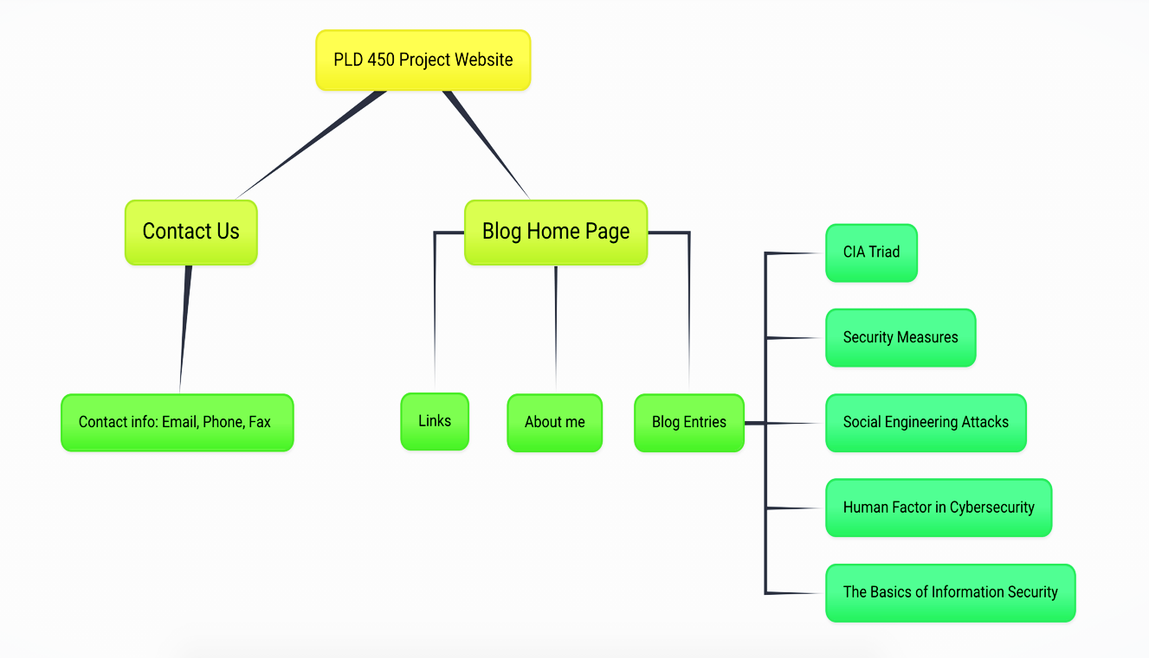

PLD450 blog website mind map

**Development, Testing, and Deployment phases**

I decided to put these three phases together because I used an Agile approach, which involves testing early and often, to catch issues and fix them practically at runtime (Sommerville, 2011).

The first step of the development phase was to set up my environment. I created several GitHub repositories, in order to test several ideas in real-time and compare the results. I had to read some documentation to get myself up to speed regarding effectively using GitHub as a repository, HTML and CSS. My go-to resource was the [www.w3schools.com](http://www.w3schools.com) website, which introduced me to concepts even beyond my current knowledge.

Once comfortable enough, I created a few files that I needed for the repository, including the bootstrap CSS file, which I used for styling, and a few pictures to make my page more colorful. I created the index.html one to enter my code.

I struggled a little bit with externally referencing a CSS file since I was used to doing it in line. Once I figured it out, it was just a repetition of coding per my requirements, deploying since GitHub continuously updates your site as you save code, and testing to see if the results were the ones I expected. I continued this process until I was satisfied with the result.

**CONCLUSION**

It has been 6 long years since I started this degree, and this project is the culmination of it. There were a lot of roadblocks, unexpected life situations, and frustrations but as I am getting close to the end, I reflect on the work done, and I am grateful for the experience and accomplishment. I had the opportunity to work with a lot of knowledgeable people, I learned a lot and the time and effort furnished were definitely worth it. This website blog that I named PLD450 is my personal reminder that with enough effort, patience, and knowledge you can reach any goal you set.

# References

Sommerville, I. (2011). Agile software development. Software engineering (9th ed., pp. 41-42). Upper Saddle River, NJ: Addison-Wesley